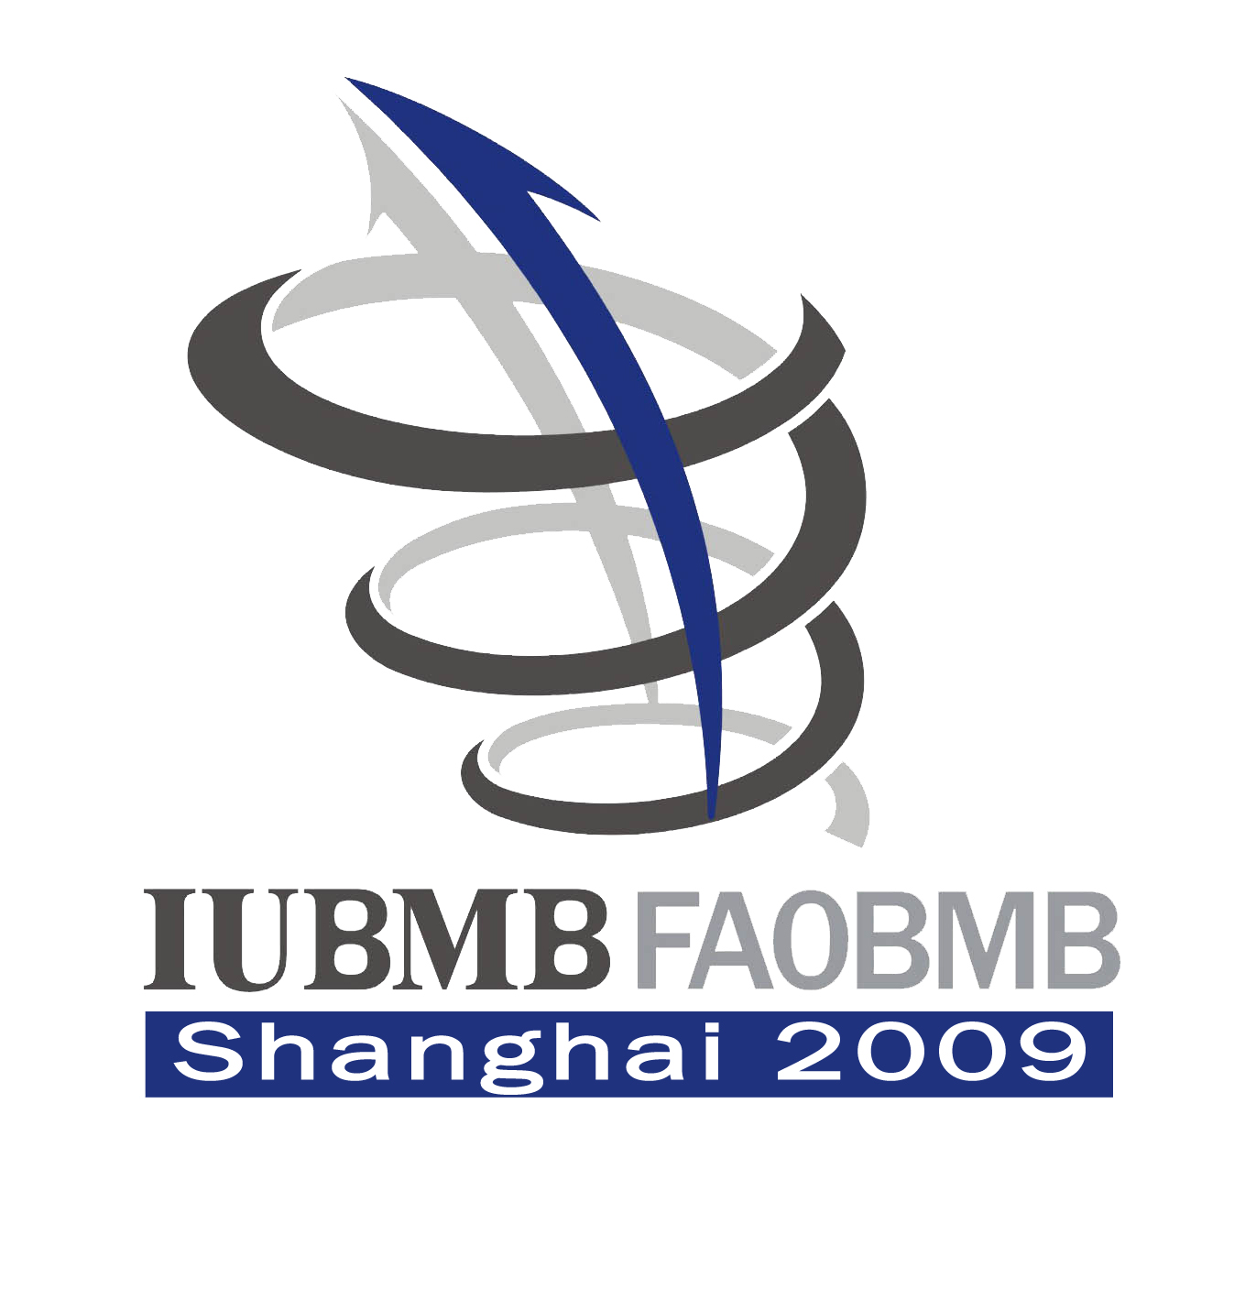
21st IUBMB and 12th FAOBMB
International Congress of Biochemistry and Molecular Biology

August 2-7, 2009, Shanghai, China

The 21st IUBMB and 12th FAOBMB International Congress of Biochemistry and Molecular Biology (2009-Congress) will take place in Shanghai on 2-7 August, 2009. The Chinese Society of Biochemistry and Molecular Biology will host this prestigious Congress.
The 2009-Congress will offer comprehensive advances at the cutting edge of biochemistry and molecular biology, which cover four major themes of life sciences (Genome Dynamics and Gene Regulation; Protein Structure, Dynamics and Proteomics; Cell Signaling and Network; Molecular Basis of Diseases) with a total of 36 symposia; it will also provide additional symposia such as glycobiology and biotechnology.
The Organization Committee has put the greatest effort to invite the world leading scientists to give presentations in the Congress. So far 12 plenary speakers, including four Nobel Laureates, Drs. Luc Montagnier, Aaron J. Ciechanover, Kurt Wüthrich and Sidney Altman, as well as Dr. Shinya Yamanaka who discovered iPS cells and Dr. Victor Ambros who discovered microRNA, have confirmed their participation. In addition, 158 invited speakers have also been confirmed and will give presentations in the different symposia.
The Organization Committee invites you, your colleagues and students to attend this prestigious Congress. The registration is opened from January 1st 2009. For more information and registration online, please visit the following website: http://www.iubmb-faobmb2009.cn
The deadline for registration and abstract submission is July 1st, 2009

Confirmed Plenary Speakers
1, Feodor Lynen Lecture and Medal Luc Montagnier
2008 Nobel Laureate in Physiology and Medicine, Fondation Mondiale Recherche & Prévention SIDA, UNESCO, France
2，EMBO Lecture Aaron J. Ciechanover
2004 Nobel Laureate in Chemistry, Technion-Israel Institute of Technology, Haifa, Israel
3, IUBMB Life Lecture and Medal Kurt Wüthrich
2002 Nobel Laureate in Chemistry, Swiss Federal Institute of Technology Zürich, Switzerland
4, Severo Ochoa Lecture and Medal Sidney Altman
1989 Nobel Laureate in Chemistry, Yale University, USA
5, Osamu Hayaishi Lecture and Medal Shinya Yamanaka
Kyoto University, Japan
6, E. C. Slater Lecture and Medal Robert G. Roeder
Rockefeller University, USA
7, Kunio Yagi Lecture and Medal Gregory J. Hannon
Howard Hughes Medical Institute, Cold Spring Harbor Laboratory, USA
8, Chester Beatty Lecture and Medal Victor Ambros
University of Massachusetts Medical School, USA
9, FAOBMB, Svasti Lectureship Gang Pei
Tongji University, China
10, European Federation of Biotechnology Mathias Uhlén
Royal Institute of Technology, Sweden
11. FEBS Lecturer Wolfgang Baumeister
Max-Planck-Institute of Biochemistry, Germany
12, CSBMB, Yinglai Wang Lecture Yi-Gong Shi
Tsinghua University, China

Confirmed Invited Speakers and Titles of Symposia

Theme 1：Genome Dynamics and Gene Regulation
1, DNA replication and repair
Guo-Min Li Professor of Department of Toxicology, University of Kentucky, USA
Peter Burgers Professor of Department of Biochemistry & Molecular Biophysics, Washington University, St. Louis, USA
2, Genome instability
David Chen Professor and Director, Division of Molecular Radiation Biology, Dept of Radiation Oncology, University of Texas Southwestern Medical School, USA
Frederick W. Alt Charles A. Janeway Professor of Pediatrics, Scientific Director, Immune Disease Institute，Harvard Medical School; Member of National Academy of Sciences; Foreign Member of European Molecular Biology Organization; USA
Daniel Durocher Associate Professor, Department of Molecular Genetics, University of Toronto, Canada
3, Chromatin remodeling and epigenetics
Chris Glass Professor of Cellular and Molecular Medicine and Professor of Medicine, University of California, San Diego, USA
John Lis Barbara McClintock Professor of Molecular Biology and Genetics, Cornell University, USA
Pavel Georgiev Head of the Laboratory of The Control of Genetic Processes, Institute of Gene Biology, Russian Academy of Sciences; Elected to the Academia Europaea; Russia
Shigeaki Kato Professor of Institute of Molecular and Cellular Biosciences, The University of Tokyo, Japan
4, Transcription control
Yang Shi Professor of Pathology, Harvard Medical School, USA
Karl Ekwall Professor of Molecular Biology, Karolinska Institute, Sweden
Tony Kouzarides Royal Society Research Professor, Deputy Director of The Gurdon Institute, University of Cambridge; Member of European Molecular Biology Organization; Member of the Academy of Medical Sciences, UK
5, Functional Genomics
Bing Ren The Ludwig Institute for Cancer Research; Associate Professor of Cellular and Molecular Medicine at the University of California, San Diego, USA
Huck Hui Ng Associate Professor, Genome Institute of Singapore, Singapore
Joseph R. Ecker Professor in the Plant Biology Laboratory and Director of the Salk Institute Genomic Analysis Laboratory, The Salk Institute for Biological Studies; Member of US National Academy of Sciences; President of the International Society for Plant Molecular Biology; USA
Harinder Singh The University of Chicago, USA
6, MicroRNA biology
You-Xin Jin Professor, Institute of Biochemistry and Cell Biology, Shanghai Institutes for Biological Sciences, Chinese Academy of Sciences, China
Tim W. Nilsen Professor and Director of Center for RNA Molecular Biology, Case Western Reserve University; Editor in Chief, RNA; USA
Yi-Jun Qi National Institute of Biological Sciences, China
7, Non-coding RNA and catalytic RNA
David Lilley University of Dundee, UK
Anna Marie Pyle Yale University, USA
Ya-Ming Hou Professor of Biochemistry and Molecular Biology, Thomas Jefferson University, USA
Olga Dontsova Professor, Department of Chemistry, Moscow State University, Russia
8, RNA processing and transport
Reinhard Lührmann Director, Max-Planck Institute of Biophysical Chemistry, Gortingen; Member of the EMBL Council; President-elect of the International RNA Society; Germany
Douglas Black Howard Hughes Medical Institute; Professor of Microbiology, University of California, Los Angeles; USA
Manuel Ares Professor, Department of Molecular, Cell & Develpomental Biology, University of California, Santa Cruz, USA
Masatoshi Hagiwara Professor of School of Biomedical Science, Professor of Medical Research Institute, Tokyo Medical and Dental University, Japan
9, Integration of gene expression and translational control
Alberto Kornblihtt Profesor Titular Plenario and Investigador Superior at the School of Sciences, Universidad de Buenos Aires, Argentina
Javier Caceres MRC Human Genetics Unit, Medical Research Council; Member of the European Molecular Biology Organization; UK
Anne Ephrussi Head of Developmental Biology Unit, European Molecular Biology Laboratory; Member of the European Molecular Biology Organization; Germany
Robert Singer Albert Einstein College of Medicine, USA

Theme 2: Protein Structure, Dynamics and Proteomics
1, Structure of membrane proteins
You-Xing Jiang Howard Hughes Medical Institute; Department of Physiology, The University of Texas Southwestern, USA
Bente Vilsen Professor of Physiology and Biophysics, Institute of Physiology and Biophysics, University of Aarhus; Member of the Danish Medical Research Council; Denmark
Joao Morais-Cabral Instituto Biologia Moleculare Celular, Portugal
Douglas Rees Howard Hughes Medical Institute; Professor in the Division of Chemistry, California Institute of Technology, USA
2, Dynamics and structures of macromolecular complex
Michael P. Rout Professor and Head of Laboratory of Cellular and Structural Biology, Rockefeller University, USA
Wei Yang Senior investigator, National Institute of Diabetes and Digestive and Kidney Diseases, National Institutes of Health, USA
Bob Stroud University of California in San Francisco, USA
3, Protein folding, stability and quality control
Arthur Horwich Howard Hughes Medical Institute; Professor, Department of Genetics, Yale University School of Medicine; USA
Yong-Zhang Luo Professor, Department of Biological Sciences & Biotechnology, Tsinghua University, China
Johannes Buchner Professor, Center for Integrated Protein Science Munich and Department Chemie, Technische Universität München, Germany
Usula Jakob Department of molecular, celllular and developmental Biology，University of Michigen, USA
4, Modeling and drug discovery
Glaucius Oliva Director, Instituto de Fisica de Sao Carlos,Universidade de Sao Paulo, Brazi
Ming Luo Howard Hughes Medical Institute; Professor, Department of Microbiology, University of Alabama at Birmingham, USA
Tom Blundell William Dunn Professor of Biochemistry and Chair, School of Biological Sciences, University of Cambridge; Fellow of the Royal Society; Member of EMBO; UK
R Sowhdhamini National Centre for Biological Sciences, Tata Institute of Fundamental Research, India
5, Protein trafficking
Frederick M. Hughson Associate Professor of Molecular Biology, Department of Molecular Biology, Princeton University, USA
Dirk Fasshauer Max-Planck-Institute for Biophysical Chemistry, Germany
Jenny Martin Institute for Molecular Bioscience, University of Queensland; Chair of the Australian Academy of Science National Committee for Crystallography; Australia
6, Protein profiling and interaction
Joan C. Guinovart Professor of Biochemistry and Molecular Biology, University of Barcelona; President of the Confederation of Spanish Scientific Societies; Spain
Ueli Aebi M. E. Müller Institute for Structural Biology, University of Basel, Switzerland
Xue-Liang Zhu Professor and Vice-director, Institute of Biochemistry and Cell Biology, Shanghai Institutes for Biological Sciences, Chinese Academy of Sciences, China
7, Protein modification
Zhi-Jian James Chen Howard Hughes Medical Institute; Robert McLemore Professor in Medical Science, University of Texas Southwestern Medical Center, USA
Yue Xiong William R. Kenan Jr. Professor of Biochemistry and Biophysics, University of Northern Carolina at Chapel Hill, USA
Tony Hunter Professor, Salk Institute for Biological Studies, USA
Sylvie Urbe Professor, Physiological Laboratory, University of Liverpool, UK
8, Protein degradation
Daniel Finley Professor of Cell Biology, Department of Cell Biology, Harvard Medical School, USA
Yoshinori Ohsumi National Institute for Basic Biology, Japan
Brenda Schulman Howard Hughes Medical Institute; St. Jude Children's Research Hospital, USA
Jan- Michael Peters Research Institute of Molecular Pathology, Vienna, Austria
9, Proteomics
John Bergeron Director of the Montreal Proteomics Network, Chair of the Department of Anatomy and Cell Biology, McGill University, Canada
Fu-Chu He Professor and Director, State Key Laboratory of Proteomics, Beijing Proteome Research Center, Beijing Institute of Radiation Medicine; Member of Chinese Academy of Sciences; China
Richard J. Simpson Professor, Ludwig Institute for Cancer Research & the Walter and Eliza Hall Institute of Medical Research, Melbourne, Australia

Theme 3: Cell Signaling and Network
1, Genetic reprogramming
Duan-Qing Pei Professor and Director, Guangzhou Institute of Biomedicine and Health, Chinese Academy of Sciences, China
Shinichi Nishikawa Deputy Director, Center for Developmental Biology, RIKEN Kobe, Japan
Sunghoon Kim Professor and Director, Center for Medicinal Protein Network and Systems Biology, College of Pharmacy, Seoul National University, Korea
2, Cell fate determination
An-Ming Meng Professor and Director, Institute of Zoology, Chinese Academy of Sciences; Member of Chinese Academy of Sciences; China
Stephen Wilson Department of Anatomy and Developmental Biology, University College London, UK
Shinichi Aizawa Center for Developmental Biology, RIKEN Kobe, Japan
Robert Saint Professor and Head, Molecular Genetics and Evolution; Research School of Biological Sciences, Australian National University, Australia
3, Cell cycle control
Di-Hua Yu Nylene Eckles Distinguished Professor in Breast Cancer Research, The University of Texas M. D. Anderson Cancer Center, USA
Jian Kuang The University of Texas M. D. Anderson Cancer Center, USA
Todd Stukenberg Associate Professor, Department of Biochemistry and Molecular Genetics, University of Virginia Medical School, USA
4, Signaling networks
An-Ning Lin Professor, Ben May Institute for Cancer Research, The University of Chicago, USA
Melanie H. Cobb University of Texas, Southwestern Medical Center at Dallas, USA
Gary L Johnson Professor and Chair, Department of Pharmacology, University of Northern Carolina at Chapel Hill, USA
Jean Wang Professor of Medicine, University of California, San Diego, USA
Shao-Cong Sun Professor, Department of Immunology, University of Texas MD Anderson Cancer Center, Houston, USA
5, Stem cell biology
Hai-Fan Lin Professor of Cell Biology and Genetics, Director of the Yale Stem Cell Center, Yale University, USA
Sean Morrison Henry Sewall Professor in Medicine, Director of Center for Stem Cell Biology, Cell & Developmental Biology, University of Michigan, USA
John Dick Chair in Stem Cell Biology, Toronto General Research Institute, University of Toronto, Canada
6, Bioenergetics and metabolism
Kun-Liang Guan Professor, Department of Pharmacology, University of California San Diego, USA
Dario Alessi Moffat Research Professor, Deputy Director of the MRC Protein Phosphorylation Unit, University of Dundee, UK
Rony Seger Associate Professor, Department of Biological Regulation, Weizmann Institute of Science, Israel
David Sabatini Whitehead Institute for Biomedical Research, Massachusetts Institute of Technology, USA
7, Signaling and behaviors
Horace Loh Frederick and Alice Stark Professor and Head, Department of Pharmacology, University of Minnesota, USA
Tomas Hökfelt Professor of Histology and Cell Biology, Karolinska Institutet; Member of US National Academy of Sciences; Member of Swedish Royal Academy of Sciences; Sweden
Ping-Yee Law Professor, Department of Pharmacology, University of Minnesota, USA
Paul Insel University of California at San Diego, USA
8, Regulation of cell migration
Dan Wu Professor, Department of Pharmacology, Yale Medical School, USA
Peter Devreotes Professor and Director, Department of Cell Biology, Johns Hopkins University School of Medicine; Member of US National Academy of Sciences; USA
Tobias Meyer Stanford University Medical Center, USA
Tatsuo Kinashi Professor, Department of Molecular Genetics, Institute of Biomedical Science, Kansai Medical University, Osaka, Japan
9, Membrane trafficking
Scott Emr Frank Rhodes Professor, Dept of Molecular Biology & Genetics, Cornell University; Member of US National Academy of Sciences; USA
Wan-Jin Hong Professor and Deputy Director, Cancer and Developmental Cell Biology Division, Institute of Molecular and Cell Biology, Singapore
Ye-Guang Chen Professor, Department of Biological Sciences and Biotechnology, Tsinghua University, China

Theme 4：Molecular Basis of Diseases
1.Protein misfolding and neurodegeneration
Xiao-Jiang Li Distinguished Professor of Human Genetics, Emory University School of Medicine, USA
Marie F. Chesselet Charles H. Markham Professor of Neurology, Chair of Department of Neurobiology, University of California, Los Angeles, USA
Susan Ackerman Howard Hughes Medical Institute; Professor, The Jackson Laboratory, USA
David Rubinsztein Professor of Molecular Neurogenetics, Wellcome Trust Senior Fellow in Clinical Science/ Honorary Consultant, Department of Medical Genetics, University of Cambridge; UK
2. Molecular mechanism of cancer
Yosef Yarden Professor, Department of Biological Regulation, The Weizmann Institute of Science; Member of European Molecular Biology Organization; Israel
Axel Ullrich PhD Professor, Max-Planck-Institute of Biochemistry, Germany
M. Iqbal Parker Professor, Institute of Infectious Disease and Molecular Medicine, University of Cape Town, Cape Town, South Africa
Sergey Nedospasov Professor and Head, Laboratory of Molecular Immunology, Engelhardt Institute of Molecular Biology, Russian Academy of Sciences, Moscow, Russia
3. Apoptosis and autophagy
Jun-Ying Yuan Professor of Cell Biology, Harvard Medical School; Fellow of the American Academy of Arts and Sciences; USA
Eileen White Associate Director for Basic Science, The Cancer Institute of New Jersey; Professor, Molecular Biology and Biochemistry, Rutgers University, USA
Noboru Mizushima Professor, Department of Physiology and Cell Biology, Tokyo Medical and Dental University, Japan
J. Marie Hardwick Johns Hopkins University School of Medicine, USA
4. Bacterial and viral infection
Maria G. Masucci Karolinska Institutet, Sweden
Brigitte Gicquel Institut Pasteur, France
Jian-Dong Li Professor, Department of Microbiology & Immunology, University of Rochester Medical Center, USA
Sergey N. Kochetkov Professor, Engelhardt Institute of Molecular Biology, Russian Academy of Sciences, Moscow, Russia
5. Stress responses and aging
F. Ulrich Hartl Professor and Director, Max Planck Institute of Biochemistry; Member of European Molecular Biology Organization; Germany
Richard Morimoto Northwestern University, USA
Kazuhiro Nagata Professor and Chairman, Department of Molecular and Cellular Biology, Institute for Frontier Medical Sciences, Kyoto University, Japan
Gordon Lithgow The Buck Institute for Advanced Age Research, Novato, California, USA
6. Immunological and inflammatory disorders
Ke Shuai Professor, Division of Hematology/Oncology, Department of Medicine, Department of Biological Chemistry, University of California, Los Angeles, USA
Michael Karin Professor, Department of Pharmacology, University of California, San Diego; Member of US National Academy of Sciences; USA
David Wallach Professor, Department of Biological Chemistry, Weizmann Institute of Science, Israel
Zheng-Gang Liu Senior Investigator, National Institutes of Health/National Cancer Institute, USA
7. Molecular diagnostics and therapeutics
Min Li Professor, Department of Neuroscience, Johns Hopkins University School of Medicine; USA
John A. Blaho Head, Virology Research Division , Molecular Diagnosis Laboratory Co.; Professor of Microbiology, Mount Sinai School of Medicine; Professor of Molecular Biology, University of Medicine & Dentistry of New Jersey; USA
Samit Adhya Head, Division of Molecular and Human Genetics, Indian Institute of Chemical Biology, Fellow of Indian National Science Academy, India
Valentin V. Vlassov Professor, Institute of Chemical Biology, Fundamental Medicine Siberian Division, Russian Academy of Sciences, Russia
8. Metabolic regulation and dysfunction
David James Director and NHMRC Senior Principal Research Fellow, Diabetes and Obesity Research Program, Garvan Institute of Medical Research, Sydney; Fellow of the Australian Academy of Science; Australia
Morris Birnbaum Professor, Department of Pharmacology, University of Pennsylvania School of Medicine; Deputy Editor, Journal of Clinical Investigation; USA
Jae Bum Kim Professor, School of Biological Sciences, Seoul National University, Korea
Tao Xu Professor and Director, Institute of Biophysics, Chinese Academy of Sciences, China
9. Cancer stem cells and metastasis
Jun-Lin Guan Professor, Department of Internal Medicine-Division of Molecular Medicine and Genetics, University of Michigan Medical School, USA
Fiona Watt Herchel Smith Professor of Molecular Genetics, University of Cambridge; Deputy Director, Cancer Research UK Cambridge Research Institute; Deputy Director, Wellcome Trust Centre for Stem Cell Research; Member of European Molecular Biology Organization; Fellow of Academy of Medical Sciences; Fellow of Royal Society; Editor-in-Chief, Journal of Cell Science; UK
Stephen J. Weiss E. Gifford and Love Barnett Upjohn Professor of Internal Medicine and Oncology, Division Chief, Molecular Medicine and Genetics, Department of Internal Medicine, University of Michigan, USA
Geoff Lindeman The Walter and Eliza Hall Institute of Medical Research, Australia

Symposium of Glycobiology
Richard D. Cummings William Patterson Timmie Professor and Chair, Department of Biochemistry, Emory University School of Medicine, USA
Tong-Zhong Ju Assistant Professor of Biochemistry, Emory University School of Medicine, USA
Irma van Die Department of Molecular Cell Biology & Immunology, University Medical Center, Amsterdam, The Netherlands
Naoyuki Taniguchi Center for Advanced Science & Innovation, Osaka University, Japan
Hisashi Narimatsu Director,Research Center for Medical Glycoscience, National Institute of Advanced Industrial Science and Technology, Japan

Symposium of Biotechnology and Technology Transfer
Christian Mandl Novartis Vaccines and Diagnostics, Inc, USA
Kathrin U. Jansen Wyeth Vaccine Research, Inc, USA
T. Mark Doherty Department. of Infectious Disease Immunology, Statens Serum Institut, Copenhagen, Denmark
Cornelis J.M. Melief Leiden University Medical Center, The Netherlands
Alexander von Gabain Intercell AG, Vienna, Austria
Alexander Gabibov Professor Lomonosov, Moscow State University, President of Russian Biochemical Society,Member Russian Academy of Sciences, Russia

Symposium of History and Education of Biochemistry
Judith Voet Professor, Chemistry Department, Swarthmore College, Swarthmore, USA
Donald Voet Chemistry Department, University of Pennsylvania, USA
Thomas Baldwin Professor and Dean, UCR Science, College of Natural and Agricultural Science, University of California at Riverside, USA
Eduardo Galembeck Professor, Departamento de Bioquímica - Instituto de Biologia, Universidade Estadual de Campinas, Brasil
Hoon Eng Khoo Provost and Acting Vice-Chancellor, Asian University for Women, Bangladesh
Michel Morange Professor, Unite de Genetique Moleculaire, Departement de Biologie, Ecole Normale Superieure (ENS), Paris, France
Hans-J. Rheinberger Professor and Executive Director, Max Planck Institute for the History of Science, Germany
Bruno Strasser Assistant Professor of History of Science & Medicine, Department of History, Yale University, USA
Susan Hamilton Professor, Academic Board Office, University of Queensland, Australia
Manuel J. Costa Assistant Professor of Medical Education, School of Health Sciences Universidade do Minho, Portugal
Duane W. Sears Professor, Department of Molecular, Cellular and Developmental Biology, University of California, Santa Barbara, USA
Trevor R. Anderson Head, Science Education Research Group (SERG) and Associate Professor in Biochemistry, School of Biochemistry, Genetics & Microbiology, University of KwaZulu-Natal, P/Bag X01 Scottsville 3209, South Africa

